HONG KONG INSTITUTE OF VOCATIONAL EDUCATION
Laboratory 3b: Instance and Static Members

TASK:

1. Modify the following program to displays the output shown below:

class Vehicle:
# Important:
# All variables except constants should be declared as non-public
MAX_NUM_WHEELS = 16
MIN_NUM_WHEELS = 2
DEFAULT_NUM_WHEELS = 4
__total_vehicle = 0

def __init__(self, num_wheels):
self.__total_vehicle += 1
if (num_wheels < Vehicle.MIN_NUM_WHEELS or
num_wheels > Vehicle.MAX_NUM_WHEELS):
self.__num_wheels = Vehicle.DEFAULT_NUM_WHEELS
else:
self.__num_wheels = num_wheels

if __name__ == "__main__":
my_car = Vehicle(4)
my_truck = Vehicle(Vehicle.MAX_NUM_WHEELS)
my_bike = Vehicle(Vehicle.MIN_NUM_WHEELS)

print(f"My car has {my_car.__num_wheels} wheels")
print(f"My truck has {my_truck.__num_wheels} wheels")
print(f"My bike has {my_bike.__num_wheels} wheels")
print(f"There are {Vehicle.__total_vehicle} vehicle(s)")

Sample output:
My car has 4 wheels
My truck has 16 wheels
My bike has 2 wheels
There are 3 vehicle(s)
Hints: All variables except constants should be declared as non-public and obtained by public getter methods in client program (data encapsulation rule)
Answer:
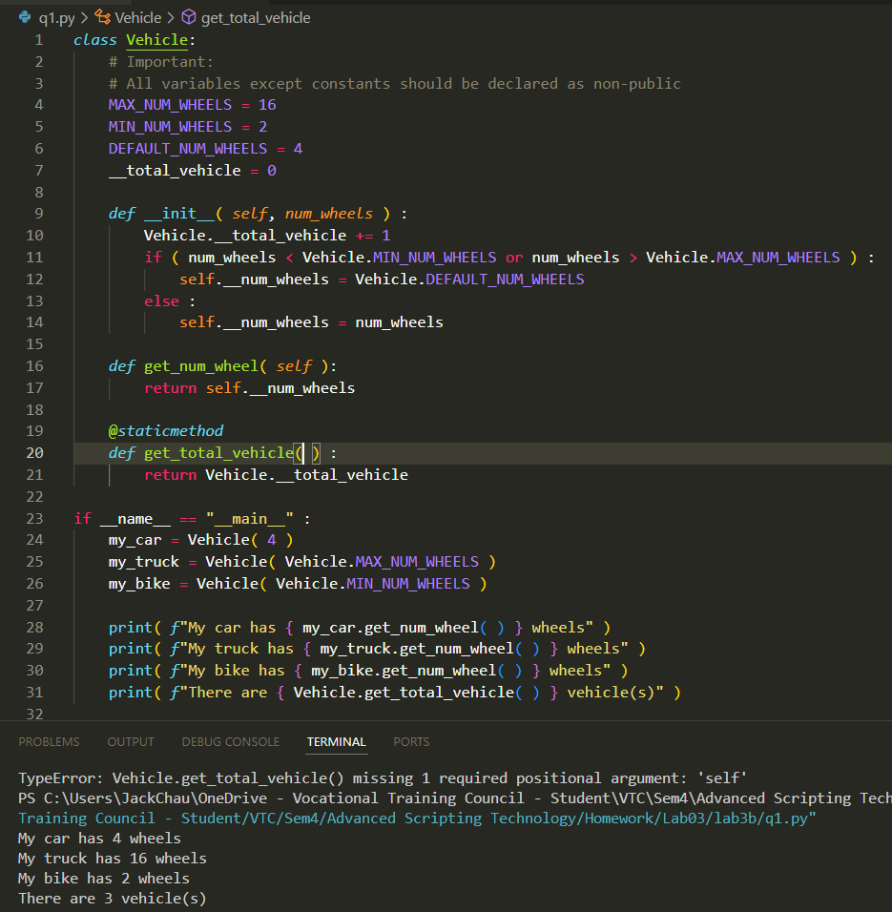

2. Write a supplier class and client / driver program in the following parts below:
(a) Create a class Employee that has:
Employee
__name : str
__salary : float
__number_of_employee : int
__total_salary_expense : float
__init__ (self, name, salary)
set_salary (self, salary)
raise_salary (self, percentage)
display (self)
get_average_salary() : float
Attributes:
__name – to store the name of the employee
__salary – to store the current sa__lary of the
employee
__number_of_employee – a static variable to
store the total number of employees
created
__total_salary_expense – a static variable to
store the total salary expense of all
employees
Methods:
__init__ – initialize the name and salary
Attribute in employee object. Add 1 to
Number of employee and add salary to
Total salary expenses when employee
object is created
set_salary – if the salary being update is greater
than 0, minus the current salary from
total_salary_expense first, update the
current salary of employee object’s and then add it to total_salary_expense
raise_salary – to raise the salary of the employee by percentage given.
Note: you have to perform all the operations in the set_salary method, such
as checking for salary > 0, minus the current salary from
total_salary_expense, update the raised salary and add it to
total_salary_expense
display – to print the output with the sample given
get_average_salary – a static method to return the average salary of all employees
Answer:

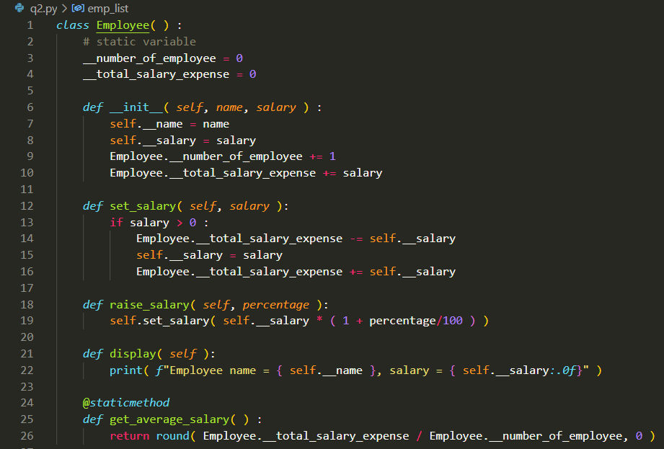

(b) Complete the following client / driver program that will do the following:
- Create a list named emp_list to hold all employee objects
- Create an employee object with name “Chan Tai Man” and salary 12000. Add it to the list you created in step 1
- Create an employee object with name “Tam Ping Shing” and salary 13500. Add it to the list you created in step 1
- Create an employee object with name “Leung Pig Hung” and salary 15000. Add it to the list you created in step 1
- Print the name and salary of the three employee objects as shown in the sample output by calling the employee display method.
- Print the average salary of employee objects created as shown in the sample output by calling the static method get_average_salary.
- Raise the salary of employee “Chan Tai Man” by 10%.
- Raise the salary of employee “Tam Ping Shing” by 5%
- Set salary of employee “Leung Pig Hung” to 9000
- Print the employee information and average salary again as shown in the sample output.

Sample output:
Before:
Employee name=Chan Tai Man, salary=12000
Employee name=Tam Ping Shing, salary=13500
Employee name=Leung Pig Hung, salary=15000
Average salary is 13500.0
After:
Employee name=Chan Tai Man, salary=13200
Employee name=Tam Ping Shing, salary=14175
Employee name=Leung Pig Hung, salary=9000
Average salary is 12125.0

if __name__ == "__main__":
# 1 Create a list named emp_list to hold all
# employee objects

# 2 - 4 Create employee object with name and salary
# Add it to the list you created in step 1

print ("Before:")
# 5 Use looping and call display method to print
# employee information

# 6 Print average salary of employee objects

print ("After:")
# 7 Raise salary of employee "Chan Tai Man" by 10%

# 8 Raise salary of employee "Tam Ping Shing" by 5%

# 9 Set salary of employee "Leung Pig Hung" to 9000

# 10 Print employee information and average salary again

Answer:

